
MANUFACTURED HOUSING DIVISION | 5500 SAN ANTONIO DR NE, ALBUQUERQUE, NM 87109
(505) 222-9801 | RLD.NM.GOV/MANUFACTURED-HOUSING-DIVISION

Permitting Portal User Guide

Contents
LOGIN
Register as a Homeowner 3
Search Notices 8
Search Permits 10
Request an Investigation 12
Complete Profile Registration 16
Licensed Professionals 17
Community Admin Actions 17
Adding a User 17
Revoking Access for a User 20
Licensed Professional Permit Application 22
Homeowners 32
Homeowner Permit Application 32
Installation/Installation & Foundation Permits 36
Add a Contractor 36
Approve/Decline Scope of Work 39
Request Installation Scope of Work 43
Ticket Management 47
Request for Address Change 47
Withdraw a Permit 50
Cancel a Permit 53
Help Desk 56
Request Inspections 58
Pre-Inspection 58
Final Inspection 60
Re-Inspection 62
Request for Removal of Prohibited Sales Notice 66
Picture Uploads 69

Login Page

Register as a Homeowner

1 | To register as the homeowner, users will need to navigate to the following link:  https://nmrld.my.site.com/MHD/s/login/. Once they navigate to the link, they will need to click on the “Register as Homeowner” button.  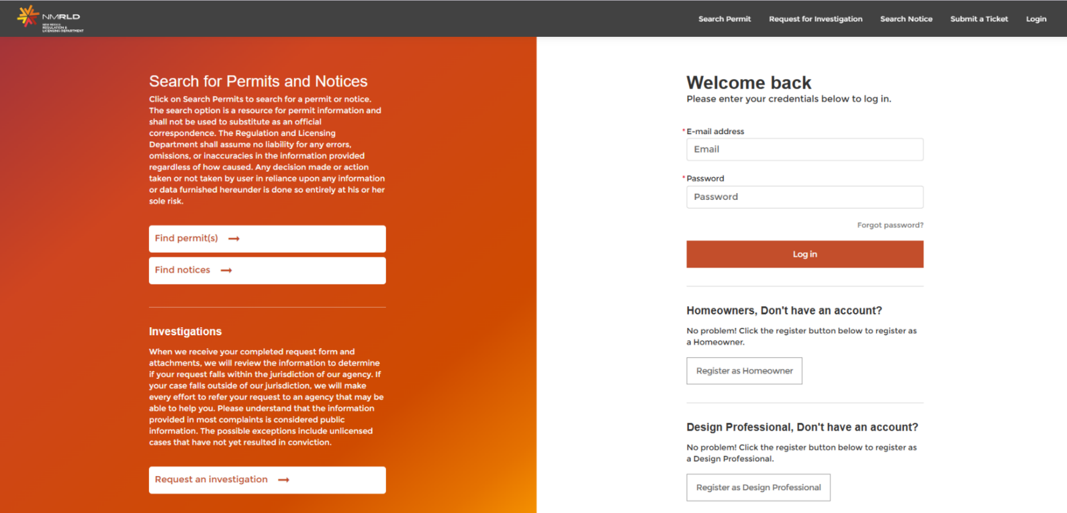
2 | After clicking on the button, the user will be prompted to fill in the required information for registration. Please fill in the details and click on submit.  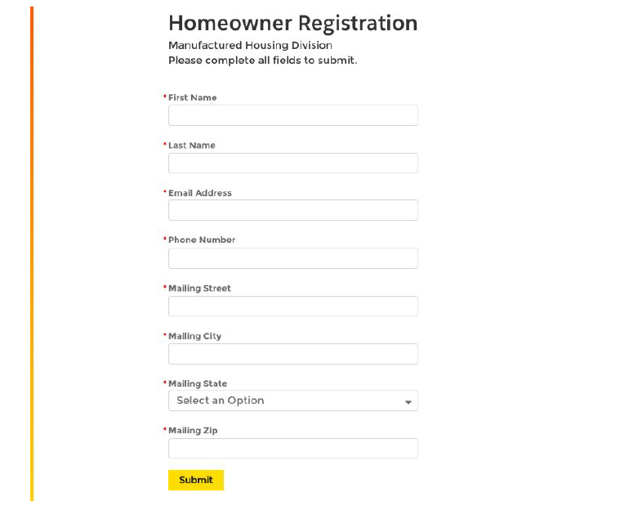
3 | After a successful submission, the user will receive a confirmation on the screen.  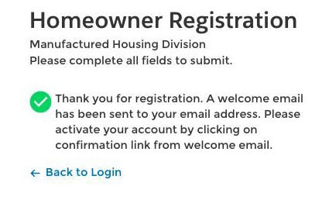
4 | To activate the account, users should access the welcome email and click on the link to continue with the registration process.
5 | The user will be redirected to the page where the password has to be generated. Please follow the instructions for the password and create a password for your account.
6 | After the user generates the password for their account, they will be redirected to the “My Profile” section where they need to complete the information on the page to continue with the portal. Click on “Edit,” fill in the information and then click on “Save to update the changes.

Search Notices

1 | The user can search for notices from the home page of the community portal. To search for a notice, click on the “Search for Notice button at the top right of the page.
2 | Once the user clicks on the button, he or she will be redirected to the page where they can share a notice number. The user can search for the notice from either of the following:  - Notice Number  - Record Id  - Licensee Responsible  - Address  Choose a type to search, fill in the information, and click on “Search.” The user will then see all the notices related to the search mentioned.

Search Permits

1 | The user can search for permits from the home page of the community portal. To search for permits, click on the “Search Permit(s)” button at the top right of the page.
2 | Once the user clicks on the button, he or she will be redirected to the page where he or she can share the notices. The user can search for the notice from either of the following:  - Record Id  - Permit Holder Name  - License Number  - Licensee Name  - Address  Choose a type to search, fill in the information, and click on “Search.” The user would get all the permits related to the search mentioned.
3 | Let’s try searching for all the permits held by Kiran. For the same, click on Permit Holder Name and write “Kiran” in the text box and click on Search.

Request an Investigation

1 | The user can request for investigation from the home page of the community portal. To request an investigation, click  on “Request an investigation” button at the top right corner of the page.
2 | Once the user clicks on the button, they will automatically navigate to the page where they can submit the information  related to the investigation.
3 | Step 1, fill the information including:  - Type of Complaint  - Division  - What is the state of the work  - Last Date of Work or Action  Once you fill in the information click on Next to continue.
4 | On Step 2, fill in the information on the respondent. Please note that the fields with the red asterisk mark (*) are the  required field and the others are optional to fill in. Fill all the requisite information and click on “Next” to continue.
5 | Fill in the project details on Step 3 and click on Next to move to the complaint information. On complaint information,  the user will need to fill in the details of the complaint and click on Next to move further. Acknowledge the investigation  request and click on either:  - Submit  - Submit with document
6 | When the user clicks on “Submit with Document,” they will be redirected to the “upload document” screen. They can  upload the document and click on “Close” to submit the request for an investigation.
7 | After the process is completed, the user will receive the message on the screen with the request number for the  investigation.

Portal

Complete Profile Registration

1 | To complete the profile information, the user should click on “My Profile” at the top right corner of the page below the name of the user.
2 | Once the user clicks on My profile, they will be redirected to the My Profile page where they can edit the profile details.  To edit the details, click on “Edit.” Then fill in the information and click on save to update the changes. Please note: to be compliant with the Parental Responsibilities Act, licensees must submit their social security number.  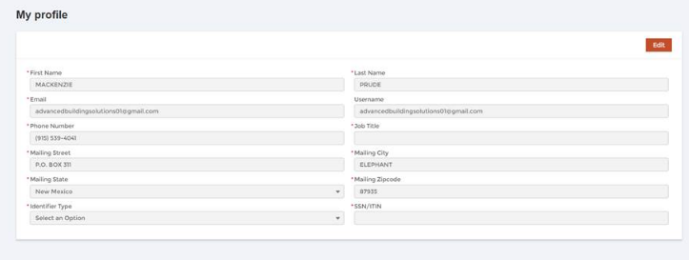

Licensed Professionals

Community Admin Actions

Adding a User

1 | Login to the community portal with the help of the credentials. Navigate to the community admin tab from the panel  available on the left side of the page and click on it.
2 | Once the user clicks on “Community Admin,” they will be redirected to the page for community admin. From there, click on the “Add New User” button to add a new user to the community.
3 | Fill in the requisite information and click on Save to create a new user in the community.
4 | After clicking on Save, the user record will be created and it will be available in the list of users.  The user can manage the list of users who are authorized to pull permits and request inspections on behalf of the  organization.

Revoking Access for a User

1 | Login to the community portal with the help of the credentials. Navigate to the community admin tab from the panel  available on the left side of the page and click on it.
2 | Click on the community tab and the user will see the list of available users in the system. The user could see the list of  available users in the system. From the list, choose the user for which the access has to be revoked and click on the  “Remove Access” button.
3 | The user will be prompted to confirm the action. Click on Yes to continue and the access will be revoked for the user.

Licensed Professional Permit Application

1 | Login to the community portal with the help of the credentials. Navigate to the manage permits tab from the panel  available on the left side of the page and click on it.
2 | When the user clicks on the Manage Permits tab, he will be redirected to the page of managing permits. They can see different options on the page. Now click on “Apply for a new permit.”
3 | After clicking on the button, the user will be redirected to the new permit application page. The user can see a list of 7  steps to be completed for a new application. Let’s look step by step on how and what to fill in these steps.
4 | On Step1, choose the permit type and click on “Next.”
5 | When the user clicks on Next, they will be redirected to the second page for inputs on “Scope of Work.” Click on New  and select the scope of work. Click on save and next to continue the application.
6 | Fill in the information for the address and click on Next to move to step 4.
7 | After filling in the details, reach to the next step for uploading the documents for permit. Click on upload, select the  document to upload, and click on done. Click on Next to continue.  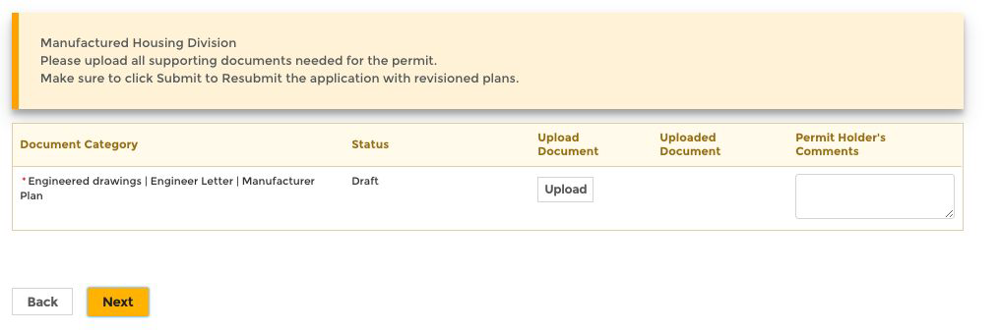
8 | On Step 6, click on the acknowledgment and move to the next.
9 | After filling in the required documents and information, the user will now be redirected to the payment page. Click on  Pay to process the payment for the permit.
10 | Choose the payment option to proceed.
11 | After clicking on the option you will be redirected to the payment gateway page. Confirm the billing information and  click on Next to continue.
12 | Complete the payment details and click on the Next button.
13 | Review the order and click on pay to finish the payment. There’s a smaller button for “Cancel Order” as well on the  page if the user wants to cancel the order at any point in time.
14 | Once the payment is complete, the user will be redirected to the portal and can see the payment completion  information. Click on the submit button to submit the permit. Upon successful submission, the user will receive the  confirmation screen saying that the permit has been received.

Homeowners

Homeowner Permit Application

1 | After registering on the portal, the homeowners can apply for permits from the homepage. To create a permit from the  portal click on the “Manage Permits” which will navigate the user to the page wherein the user can find quick links to  apply for a new permit or manage an existing permit. Click on “Apply for a new permit button” on the card of New  permit to proceed further.
2 | From there the user will be navigated to the new permit page to fill in the details. Homeowners can apply only for the  permits listed below and few of the permits do require the homeowner to go through the homeowner test as well. The  user will need to contact the Manufactured Housing Division to complete the Homeowner Examination required  Choose the permit type and click Next to move forward with the application.  On Step 2, choose the scope of work by clicking on New. The user will be given the options in the dropdown and they  should select the one that applies. Click on “Next” to move forward.
3 | Fill in the address and owner information on Step 3 and Step 4. Move to Step 5 and upload the relevant documents  for the permit. The permit holder can also put in their comments on the uploaded documents. Click on “Next” to  continue.
4 | On Step 6, the user will be presented with the acknowledgment document page wherein they will have to provide the  acknowledgment on various questions. Please go through the questions and carefully provide the acknowledgment for  every question on the screen. Once the user provides acknowledgment for the points, he or she should click on Next  to continue.
5 | The user will reach the payment information page at the end of all the steps from where they can pay for the permit.

Installation/Installation & Foundation Permits

Add a Contractor

1 | On the New Mexico RLD community portal, navigate to the manage permits tab from the panel available on the left side of the page and then apply for a new permit.
2 | On the second step of creating a permit, you can add contractors for the scope of work. Click on the pencil icon under  Action to add the contractor name. Do this for all scope of work fields.
3 | You can add another scope of work field with a contractor as well by clicking on new. Choose Work Type, Sub Work  type, type of alternative system, and then a contractor.
4 | Finish the rest of the new permit and once it is complete additional contractors will Approve or Decline the Scope of Work that was requested.

Approve/Decline Scope of Work
Note: This section should be used by the Installer/Permit holder
1 | On the New Mexico RLD community portal, Navigate to the Permits and Scope of Work tab from the panel available on the left side of the page.
2 | Find the record for the permit that you pulled. Use the whole permit number including the first 4 letters and the underscore. Under the permit number the scope of work area will show up. Here you will select the arrow on the scope of work to open details on the record.
3 | You will notice the status of each work type that are assigned to contractors. To approve the contractor after they have added themselves you can click on the approve/decline button from here. If you added them at the beginning of the permit, they will have to accept or reject in the request installation scope of work area.  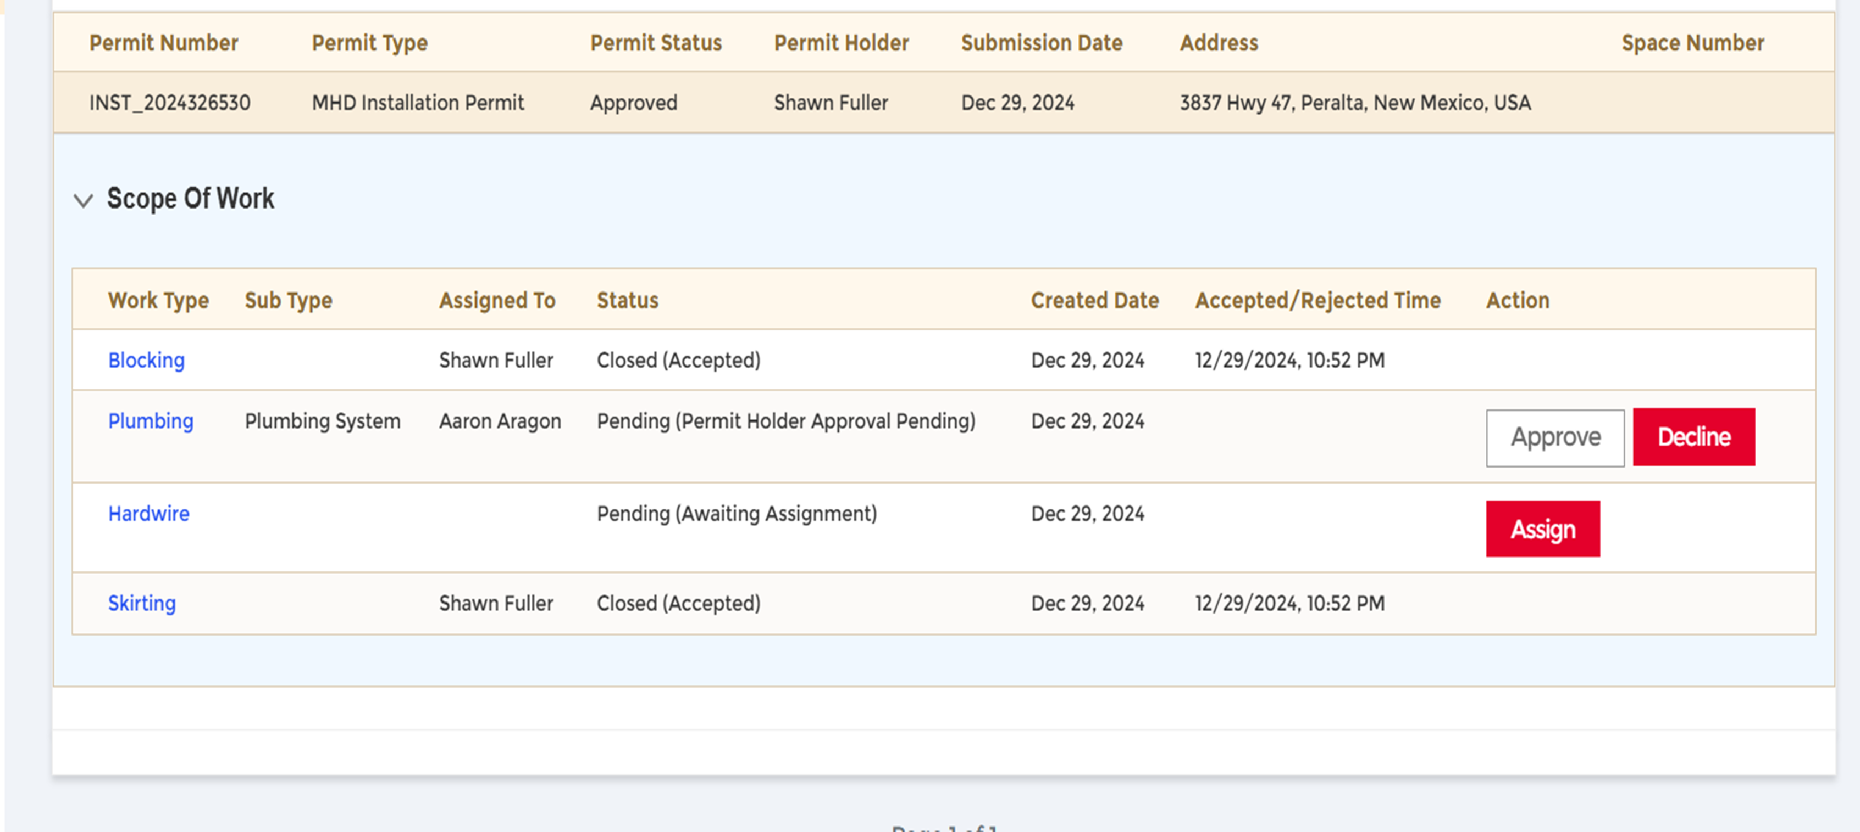
4 | Lastly, once you accept you will agree to the acknowledgment form.

Request Installation Scope of Work
Note: This section should be used by contractors approving to be added and to pull scope of work on a permit
1 | On the New Mexico RLD community portal, Navigate to the Request Installation Scope of Work tab from the panel on the left side of the page.
2 | On the record search bar, enter the permit number, address, or homeowner name to locate the permit. Please make sure to use the full permit ID, adding the first 4 letters and the underscore then the permit number provided. If you don’t do this then the permit will not populate, and system will say no records found. Once you get permit to populate, you will see a red box.  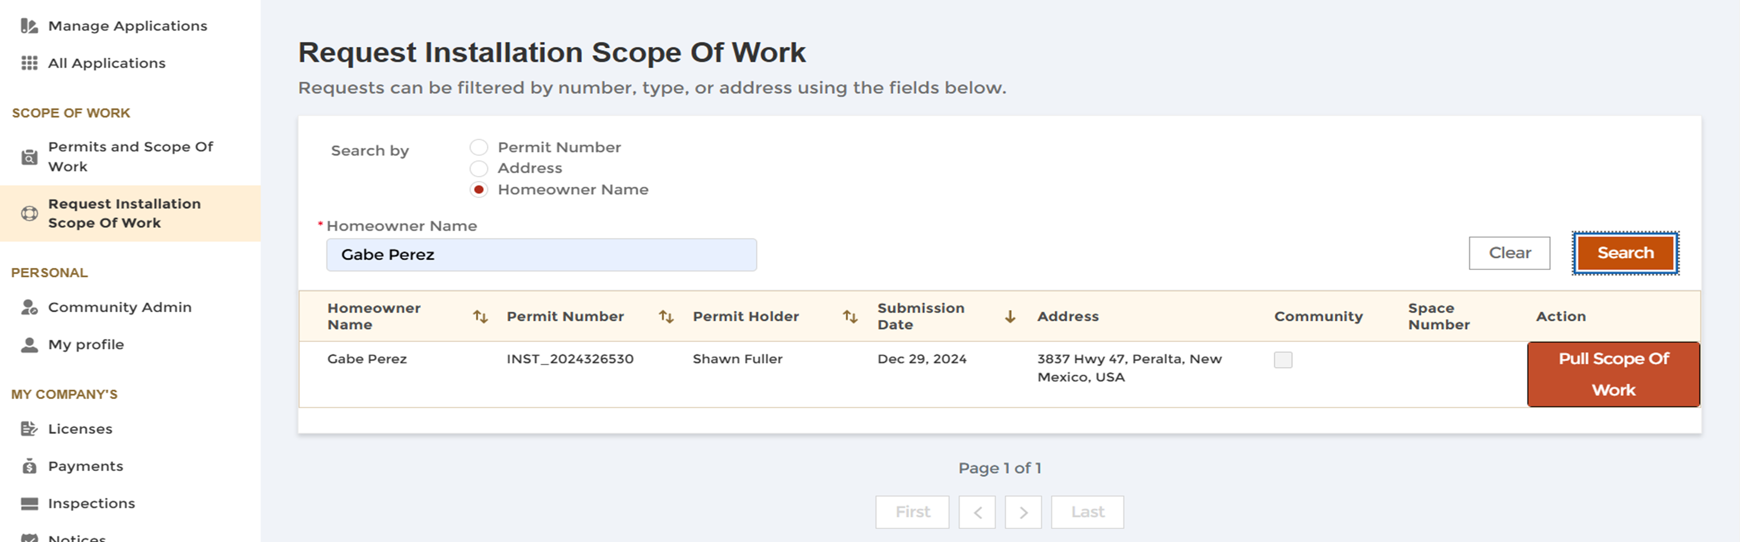
3 | Click on that red button that says “Pull Scope of Work.”
4 | Choose the Work type specific to your license classification, choose the work subtype when applicable (e.g., alternative foundation type). Lastly, agree to the acknowledgment by clicking on the box, then click save.  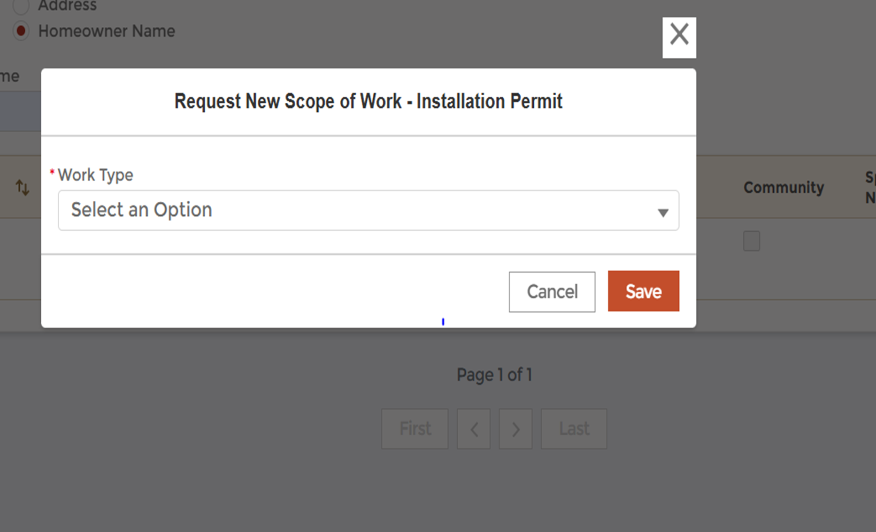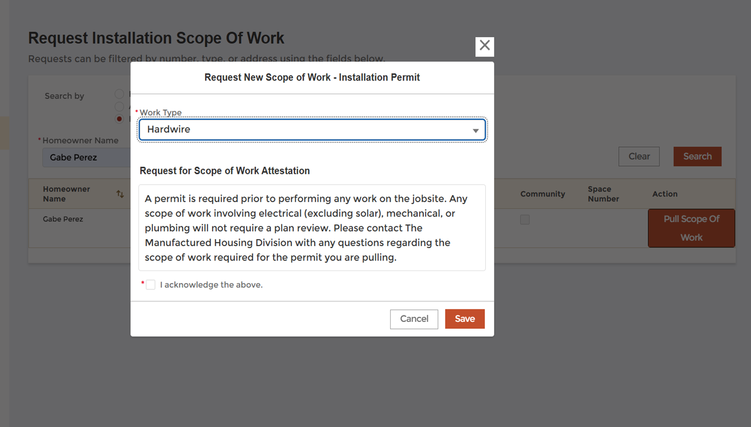
5 | If you added yourself to the permit and pulled a scope of work, the permit holder, Installer who applied for the permit will be notified via email to approve or decline contractors request for scope of work on Installation permit. Follow the steps under approve/ decline scope of work area.  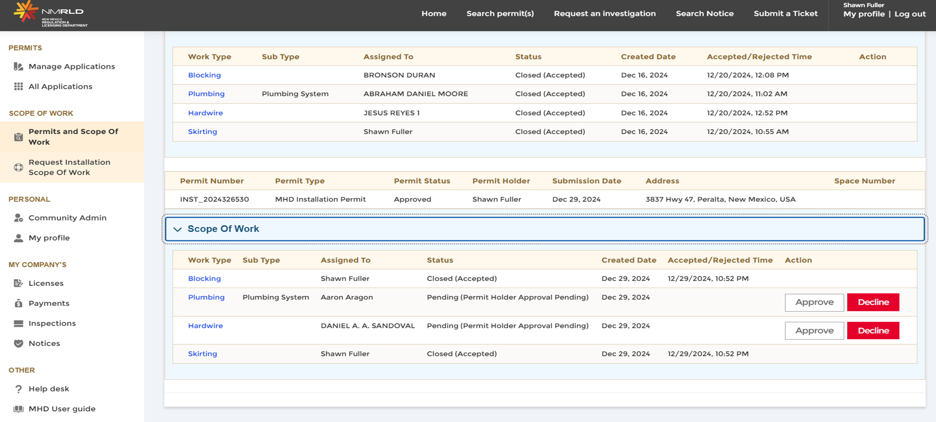

Ticket Management

Request for Address Change

1 | Login to the community portal with the help of the credentials. Navigate to the manage permits tab from the panel  available on the left side of the page and click on it.
2 | Click on the Change of Address card.
3 | When the user clicks on “Change an Address,” they will see a list of the permits available. Click on the change address  adjacent to the permit application on which the address has to be changed.
4 | Fill in the correct address and click on save to update the address. Once the user saves it, a request is automatically  generated for the change of address on that application.

Withdraw a Permit

1 | Login to the community portal with the help of the credentials. Navigate to the manage permits tab from the panel  available on the left side of the page and click on it.
2 | Click on the “Withdraw permit(s)” card.
3 | The user will see the list of available permits on the page, click on the withdrawal permit button adjacent to the permit  for which the withdrawal is to be requested.
4 | Provide the confirmation and click on confirm to save the changes.

Cancel a Permit

1 | Login to the community portal with the help of the credentials. Navigate to the manage permits tab from the panel  available on the left side of the page and click on it.
2 | Click on the Cancel a Permit card.
3 | Once the user clicks on the button, they will be redirected to the cancel permit page. The user should fill in the  information on the page and click confirm.
4 | The user will be prompted with a screen to confirm the action. They should fill in the cancellation reason, explanation,  and click on confirm to finalize canceling the permit application.

Help Desk

1 | Using the help desk button, the user can raise their concerns and requests quickly. To raise a help desk  request, the user should navigate to the “Help desk” button on the bottom of the left side panel. Click on the button.
2 | Once the user clicks on the button they will be redirected to the help desk page. Here the user can see all the  available requests, create a new request, and can filter them by number, status, and type using the fields on the page.
3 | To create a new request, click on the “New” button. Once the user clicks on the new button, they will be prompted to  fill in the details for the request. Fill in the details and click on Save.
4 | After successfully submitting the request, the user can see that the request now appears in the list and there are  actions associated with it, which the user can perform.  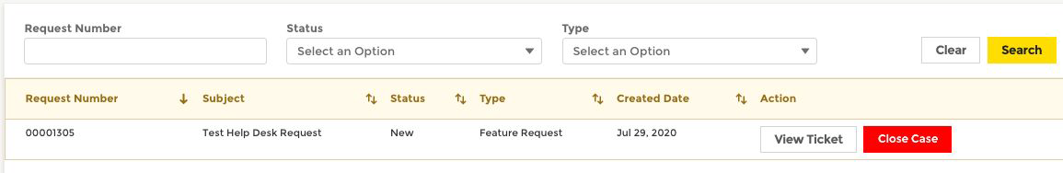

Request Inspections

Pre-Inspection

1 | To request a pre-inspection on the permit application, the user will have to navigate to the manage permits tab on the  left side of the page. Here the user will see the quick links to apply for a new permit or manage an existing permit. Click  on the “Request a pre-inspection” button on the Request Pre-Inspection card.
2 | The user will be redirected to the page for inspections and there they can see the available permits applicable for  pre-inspection. Click on the “Request Inspection” button adjacent to the permit.
3 | Once they click on the button, there will be a confirmation modal that will pop up. The user should click on Confirm to  raise the request for inspection.

Final Inspection

1 | To request a final inspection on the permit application, the user will have to navigate to the manage permits tab on the  left side of the page. Here the user will see the quick links to apply for a new permit or manage an existing permit. Click  on the “Request a final-inspection” button on the Request Final Inspection card.
2 | The user will be redirected to the page for inspections and there they can see the available permits applicable for final inspection. Please be advised all scopes of work will need to be accepted and closed before final can be requested. If all scopes are closed and accepted, click on the “Request Inspection” button adjacent to the permit.  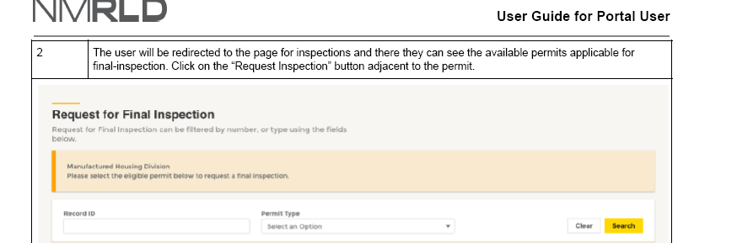
3 | Once they click on the button, there will be a confirmation that will pop up. The user should click confirm to raise the request for inspection.

Re-Inspection

1 | Upon Failure of an Inspection, the user will be eligible to request a Re-Inspection on the Portal. This can be done by  clicking on the Manage Permits Tab.
2 | Access the Request Re-Inspection title.
3 | Click on Request Inspection Next to the permit. In case of Installation permits, the Permit Holder as well as the Contractors who failed the initial Inspection on Scope of work assigned could request a Re-Inspection.
4 | To request a Re-Inspection, the user will have to pay the re-inspection fee. Upon clicking on Request Re-Inspection the user will be redirected to pay for the Re-Inspection to pay by Credit Card or Echeck.
5 | The Inspection request will be submitted after the successful completion of the payment.

Request for Removal of Prohibited Sales Notice

1 | To request the removal of Prohibited Sales Notice, the user will have to navigate to the manage permits tab on the left  side of the page. Here the user will see the quick links to apply for a new permit or manage an existing permit. Click on  the “Request notice removal” button on the Request Removal of Prohibited Sales Notice card.
2 | The user will be redirected to the page for requests and there they can see the permits for which they can place the  request for the removal of prohibited sales notice. Click on the “Request Inspection” button adjacent to the permit.
3 | Once the user clicks on the button, they will see a module for payment. The user can choose the payment option  and then they will be redirected to the Cybersource page to complete the payment. Users can check the billing  information and complete the payment.

Picture Uploads

1 | Navigate to the manage permits tab from the panel available on the left side of the page and click on it. Then you will click  on Picture Uploads.
2 | To Upload Pictures, click View Uploads. Click on Add Row to upload pictures and submit them for the inspector to review.

IF YOU HAVE ANY ADDITIONAL QUESTIONS, PLEASE CONTACT THE MANUFACTURED HOUSING DIVISION BY EMAIL AT MHD.INFO@RLD.NM.GOV.

